Modern Securities Ltd.
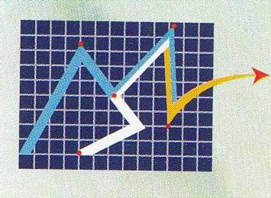
Member No. 229, Dhaka Stock Exchange Ltd
Payment Requisition Slip

Date: / / Clients Contact Number: …………………………….

CODE | NAME | AMOUNT | EFTN/  CHQ | SIGNATURE | REMARKS
*** Requisition can send by Email (info@modernsecurites.com), fax (9567027, 031-2519904 Chittagong Branch) or by calling to Tel: 7122164 ext-112, Mob:01711-321499, 01703-255319 (Mirpur Branch), 01816-279373(Chittagong Branch)
From the number provided in the BO opening form.
*** All payment will be made after preserving the minimum balance and verification.

Ext & Corp Office: 9/I, 3Rd & 4th Floor, Swantex Building, Motijheel C/A, Dhaka-1000. Tel: 7115589, 9514689, Main Office: 9/F, Room No. 209, DSE Building, Motijheel C/A, Dhaka-1000. Tel: 9563351, Mirpur Branch: 1st Floor, Parbata Tower, Mirpur-10, Dhaka-1216. Tel: 9024885, Chittagong Branch: Room # 307, Shafi Bhaban, 06, Sheikh Mujib Road, Agrabad C/A, Chittagong-4100. Tel: 031-2519902.

