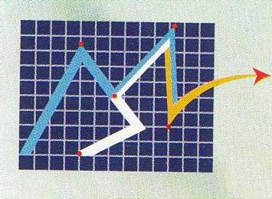
OFFICE COPY SL………….…… SL…………….

CLIENT COPY

Modern Securities Ltd. Modern Securities Ltd
TREC NO. 200229 APPLICATION FORM FOR NRB/FC TREC NO.200229
DHAKA STOCK EXCHANGE LTD DHAKA STOCK EXCHANGE LTD
DATE: CONTACT NO: DATE:

CUSTOMER  ID/CODE |  | BO ACCOUNT NO  12035700 (Last Eight Digit) |  |  |  |  |  |  |  | DRAFT INFORMATION | CURRENCY | SIGN
 |  |  |  |  |  |  |  |  |  | DRAFT INFORMATION | AMOUNT | SIGN
BANK NAME:
BR NAME:
DRAFT NO:
DATE:
NAME: |  |  |  |  |  |  |  |  |  | BANK NAME:  BR NAME:  DRAFT NO:  DATE:
BANK NAME:
BR NAME:
DRAFT NO:
DATE:
NAME: |  |  |  |  |  |  |  |  |  | BANK NAME:  BR NAME:  DRAFT NO:  DATE:
BANK NAME:
BR NAME:
DRAFT NO:
DATE:
NAME: |  |  |  |  |  |  |  |  |  | BANK NAME:  BR NAME:  DRAFT NO:  DATE:
BANK NAME:
BR NAME:
DRAFT NO:
DATE:
NAME: |  |  |  |  |  |  |  |  |  | BANK NAME:  BR NAME:  DRAFT NO:  DATE:
BANK NAME:
BR NAME:
DRAFT NO:
DATE:
NAME: |  |  |  |  |  |  |  |  |  | BANK NAME:  BR NAME:  DRAFT NO:  DATE:
CUSTOMER  ID/CODE | CURRENCY
CUSTOMER  ID/CODE | AMOUNT
PLEASE FILL ALL THE DETAILS CAREFULLY AND PERFECTLY

