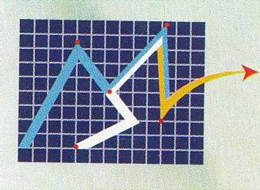
OFFICE COPY SL………….…… SL…………….

CLIENT COPY

Modern Securities Ltd. Modern Securities Ltd
TREC NO. 200229 APPLICATION FORM FOR RB/AFF(ASI) TREC NO.200229
DHAKA STOCK EXCHANGE LTD DHAKA STOCK EXCHANGE LTD
DATE: CONTACT NO: DATE:
TOTAL: TOTAL:
CUSTOMER  ID/CODE | AMOUNT | BO ACCOUNT NO  12035700 (Last Eight Digit) |  |  |  |  |  |  |  | CUSTOMER NAME | CATEGORY |  | SIGN |  | CUSTOMER  ID/CODE | AMOUNT
 |  |  |  |  |  |  |  |  |  |  | RB | AFF
 |  |  |  |  |  |  |  |  |  |  | RB | AFF
 |  |  |  |  |  |  |  |  |  |  | RB | AFF
 |  |  |  |  |  |  |  |  |  |  | RB | AFF
 |  |  |  |  |  |  |  |  |  |  | RB | AFF
 |  |  |  |  |  |  |  |  |  |  | RB | AFF
 |  |  |  |  |  |  |  |  |  |  | RB | AFF
 |  |  |  |  |  |  |  |  |  |  | RB | AFF
 |  |  |  |  |  |  |  |  |  |  | RB | AFF
 |  |  |  |  |  |  |  |  |  |  | RB | AFF
IF THE CUSTOMER ACCOUNT/CODE ALREADY CONTAINS THE IPO AMOUNT THEN FILL THE AMOUNT BOX WITH PAID
PLEASE FILL ALL THE DETAILS CAREFULLY AND PERFECTLY

